UNIT III PRACTICE SAQs

[2] Moreover, that no one may assume that the Israelites were peculiar in having kings over them who were established by God, note what is said in Ecclesiasticus: "God has given to every people its ruler, and Israel is manifestly reserved to him." He therefore governs all peoples and gives them their kings, although he governed Israel in a more intimate and obvious manner.
[3] It appears from all this that the person of the king is sacred, and that to attack him in any way is sacrilege. God has the kings anointed by his prophets with the holy unction in like manner as he has bishops and altars anointed. But even without the external application in thus being anointed, they are by their very office the representatives of the divine majesty deputed by Providence for the execution of his purposes. Accordingly God calls Cyrus his anointed. "Thus saith the Lord to his anointed, to Cyrus, whose right hand I have holden, to subdue nations before him." Kings should be guarded as holy things, and whosoever neglects to protect them is worthy of death. . . .
Jacques Benigne Bossuet (1627-1704)
Politics Derived from Holy Writ
A) Based on the excerpt above, describe ONE significant continuity in the role of government in the 17th century.
B) Based on the excerpt above, describe ONE significant change in the role of government in the 17th century.
C) Explain how ONE political theory affected the role of the people in the 17th century.

- Answer all parts of the question
Using your knowledge of European history, answer parts A, B, and C.
- Briefly explain ONE example of how new ideas in science challenged traditional views of the cosmos, nature, or the human body.
- Briefly explain a SECOND example of how new ideas in science challenged traditional views of the cosmos, nature, or the human body.
- Briefly explain ONE example of the persistence of traditional views of the cosmos, nature, or the human body.

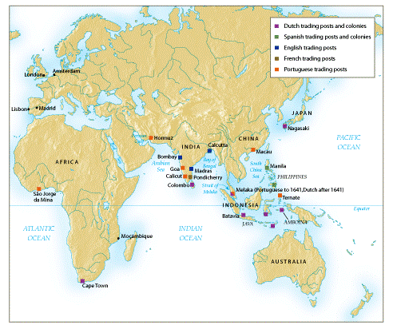

- A. Briefly explain TWO effects of the trade networks shown on the map on European economies during the 17th and 18th centuries.
B. Briefly explain ONE effect on European politics during the 17th and 18th centuries

