Name: ______________________
Period:______

Renaissance Art & Primary Source Analysis Packet

For each of the 7 major Renaissance ideas (secularism, individualism, realism, antiquity, civic humanism, liberal arts education, Christianity), you will be assigned 1 piece of art that clearly exemplifies one or more of the above Renaissance ideals. Carefully study the art piece assigned to you and your group and choose which of the ideal(s) is best depicted. Then explain why you chose that particular ideal. Be ready to participate when teacher picks you randomly. “I don’t know” is not an option in an AP course.

- 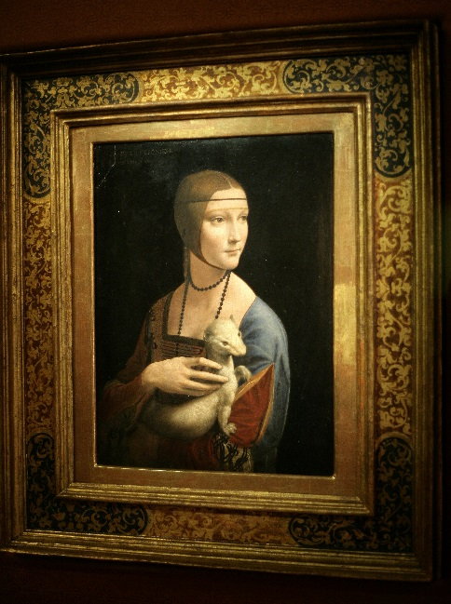
da Vinci’s Lady with an Ermine

- 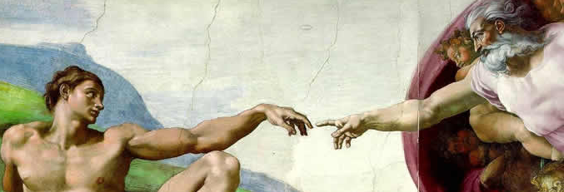
Michelangelo’s Creation of Adam

- 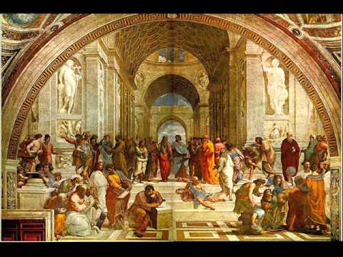
Raphael’s School of Athens

- 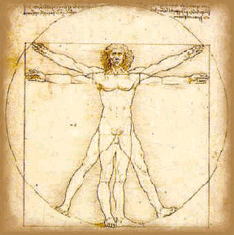
da Vinci’s Vitruvian Man

- 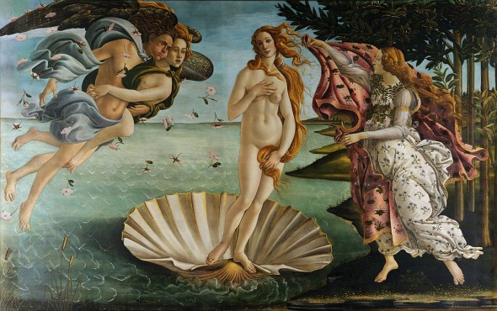
Botticeli’s Birth of Venus
- 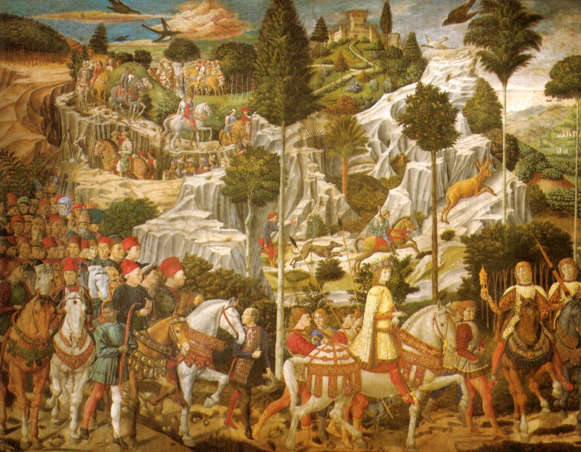
Gozzoli’s Procession of the Magi

- 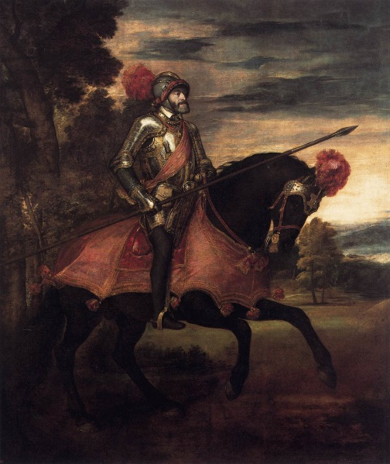
Titian’s Portrait of Emperor Charles V

- 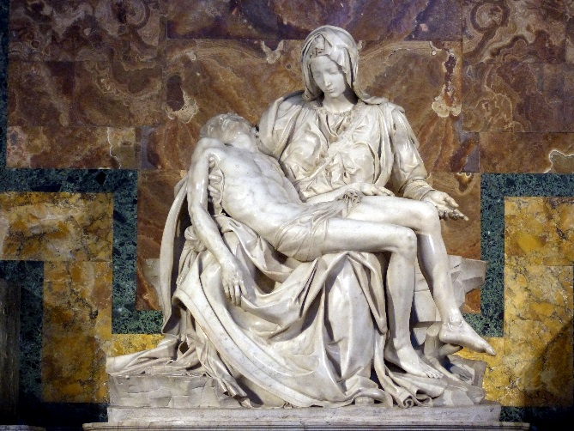
Michelangelo’s La Pieta

- 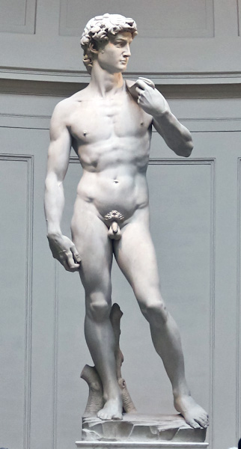
Michelangelo’s David
- 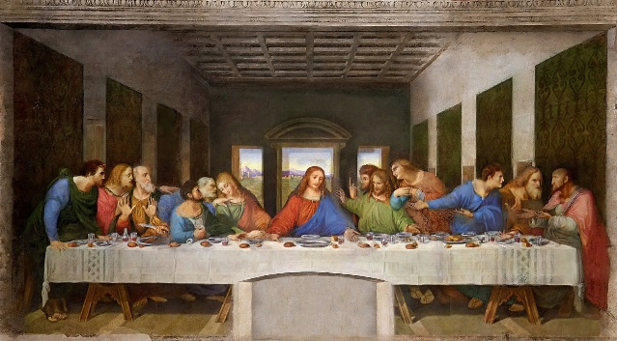
Da Vinci’s Last Supper

Once you have examined the 7 major Renaissance ideas and the works of art with your group, pick one work of art that you feel best expresses all, or most of, the ideas of the Renaissance. Write a paragraph INDIVIDUALLY in which you explain how/why that one work of art epitomizes the Renaissance. Write answer here:

Renaissance Primary Source Packet
In analyzing these docs, use APPARTS {Author, Place & Time, Prior Knowledge, Audience, Reason, The Main Idea, Significance} for the doc(s) you are assigned:

- Desiderius Erasmus, The Praise of Folly (1509), Holland
TO STUDENTS: This is a work of satire. Take it as such, remembering that a satirist typically uses humor and sarcasm to make serious points. In what ways did Erasmus contrast the Church leaders of his day with the apostles from whom they claimed to derive their authority?

The Lights of the World Reduced to a mere Wallet
In like manner cardinals, if they thought themselves the successors of the apostles, they would likewise imagine that the same things the [apostles] did are required of them, and that they are not lords but dispensers of spiritual things of which they must shortly give an exact account… they would not be so ambitious… or, if they were, they would willingly leave it and live a laborious, careful life, such as was that of the ancient apostles.
And for popes, that supply the place of Christ, if they should endeavor to imitate His life, to wit His poverty, labor, doctrine, cross, and contempt of life… who would purchase that chair with all his substance? or defend it, so purchased, with swords, poisons, and all force imaginable? …

A most inhuman and abominable thing, and more to be execrated, that those great princes of the Church and true lights of the world should be reduced to a staff and a wallet. Whereas now, if there be anything that requires their pains, they leave that to Peter and Paul that have leisure enough; but if there be anything of honor or pleasure, they take that to themselves. By which means it is, yet by my courtesy, that scarce any kind of men live more voluptuously or with less trouble; as believing that Christ will be well enough pleased if in their… ceremonies, titles of holiness and the like, and blessing and cursing, they play the parts of bishops. To work miracles is old and antiquated, and not in fashion now; to instruct the people, troublesome; to interpret the Scripture, pedantic; to pray, a sign one has little else to do; to shed tears, silly and womanish; to be poor, base; to be vanquished, dishonorable and little becoming him that scarce admits even kings to kiss his slipper; and lastly, to die, uncouth; and to be stretched on a cross, infamous.
Theirs are only those weapons and sweet blessings which Paul mentions, and of these truly they are bountiful enough: as interdictions, hangings, heavy burdens, reproofs anathemas, executions in effigy, and that terrible thunderbolt of excommunication, with the very sight of which they sink men's souls beneath the bottom of hell: which yet these most holy fathers in Christ and His vicars hurl with more fierceness against none than against such as, by the instigation of the devil, attempt to lessen or rob them of Peter's patrimony. When, though those words in the Gospel, "We have left all, and followed Thee," were his, yet they call his patrimony lands, cities, tribute, imposts, riches; for which, being enflamed with the love of Christ, they contend with fire and sword, and not without loss of much Christian blood, and believe they have then most apostolically defended the Church, the spouse of Christ, when the enemy, as they call them, are valiantly routed. As if the Church had any deadlier enemies than wicked prelates, who not only suffer Christ to run out of request for want of preaching him, but hinder his spreading by their multitudes of laws merely contrived for their own profit, corrupt him by their forced expositions, and murder him by the evil example of their pestilent life.
Folly Attends a Theological Dispute

I was lately myself at a theological dispute, for I am often there, where when one was demanding what authority there was in Holy Writ that commands heretics to be convinced by fire rather than reclaimed by argument; a crabbed old fellow, and one whose supercilious gravity spoke him at least a doctor, answered in a great fume that Saint Paul had decreed it, who said, "Reject him that is a heretic, after once or twice admonition." And when he had sundry times, one after another, thundered out the same thing, and most men wondered what ailed the man, at last he explained it thus, making two words of one: "A heretic must be put to death.” Some laughed, and yet there wanted not others to whom this exposition seemed plainly theological; which, when some, though those very few, opposed, they cut off the dispute, as we say, with a hatchet, and the credit of so uncontrollable an author. "Pray conceive me," said he, "it is written, 'Thou shalt not suffer a witch to live.' But every heretic bewitches the people; therefore, etc."
Folly Quotes Christ in Her Praise
Folly is so gracious above that her errors are only pardoned, those of wise men never. Whence it is that they ask forgiveness, though they offend never so wittingly, cloak it yet with the excuse of folly… So Saul makes his excuse of David, "For behold," says he, "I did it foolishly." And again, David himself thus sweetens God, "And therefore I beseech thee, O Lord, to take away the trespass of thy servant, for I have done foolishly," as if he knew there was no pardon to be obtained unless he had colored his offense with folly and ignorance.
And stronger is that of Christ upon the cross when he prayed for his enemies, "Father, forgive them," nor does he cover their crime with any other excuse than that of unwittingness- because, says he, "they know not what they do." In like manner Paul, writing to Timothy, "But therefore I obtained mercy, for that I did it ignorantly through unbelief." And what is the meaning of "I did it ignorantly" but that I did it out of folly, not malice? And what of "Therefore I received mercy" but that I had not obtained it had I not been made more allowable through the covert of folly? For us also makes that mystical Psalmist, though I remembered it not in its right place, "Remember not the sins of my youth nor my ignorances."
Questions to Consider: (Split questions among your group & get answers from one another. Use your answers to help you answer APPARTS.

1. Identify at least three ways that Erasmus contrasts the Church leaders of his day with the apostles.

2. According to Erasmus, is it biblical to execute heretics?

3. What is the relationship between Folly and forgiveness?

4. How is The Praise of Folly a humanistic work?

- Sir Thomas More, Utopia, England
On agriculture
They have built farm-houses over the whole country, which are well contrived and furnished with every necessary. Inhabitants for them are sent in rotation from the cities. No family in the country hath fewer than forty men and women in it, beside two slaves. A master and mistress preside over every family, and over thirty families a magistrate. Every year twenty of the family return to town after having been two years in the country and in their place other twenty are sent to learn country business of those who have been there only one year, and must, in their turn, teach the net comers. Thus, those who live on the farms are never ignorant of agriculture, and commit no fatal errors, such as causing a scarcity of corn.
On trades
Beside agriculture, so common to them, every man hath some peculiar trade, as the manufacture of wool or flax, masonry, smith’s or carpenter’s work. No other trade is in great esteem among them. Throughout the island they wear one sort of clothes, without any other distinction than what is necessary for different sexes, and the married and unmarried. The fashion, never changes, is easy and agreeable, suited to the climate, and for summer as well as winter.
On the games of the Utopians
After supper, they spend an hour in some diversion, in summer in the garden, and in winter in their halls, entertaining each other with music or discourse. They have no idea of dice, or of any foolish and mischievous game. They have, however, two games not unlike our chess. The one, a battle of numbers, in which number consumes number. The other, a contest between the virtues and vices, in which the discord among the vices themselves and their union against virtue is not unpleasantly represented; together with the particular opposition between certain virtues and vices, and the methods in which vice openly assaults, or secretly undermines virtue, and virtue resists.
On laws and Government
If a man aspire ambitiously to any office, he loseth it for certain. They live in loving intercourse with each other, the magistrates never behaving either insolently or cruelly to the people. They affect rather to be called fathers, and by really being such, well merit the appellation. The people pay them all marks of honour, the more freely because none are exacted from them. The prince himself hath no distinction either of garments or a crown; a sheaf of corn only is carried before him, and a wax-light before the high-priest.
They have few laws and such is their constitution, they require not many. They much condemn other countries, whose laws, with the commentaries on them, swell so many volumes; esteeming it unreasonable to oblige men to obey a body of laws so large and intricate, as not to be read and understood by every subject.
On Religion
Though there be many different forms of religion among them, all agree in the main point of worshipping the divine essence. Therefore there is nothing to be seen or heard in their temples, in which the several persuasions among them may not agree. For every sect performs the rites peculiar to it in their private houses, and there is nothing in the public worship which contradicts their peculiarities. There are no images of God in their temples, therefore every one may represent him to his thoughts in his own way; nor do they use for him any other name than Mithras, their term in common for the divine essence, whatever otherwise they think of it; nor have they any forms of prayer, but such as every one of them may use without prejudice to his private opinion.

- A Humanist’s Enthusiasm for Greek
One of the first humanists to have a thorough knowledge of both Latin and Greek was the Florentine chancellor Leonardo Bruni. Bruni was fortunate to be instructed by the Greek scholar Manuel Chrysoloras, who was persuaded by the Florentines to come to Florence to teach Greek. As this selection illustrates, Bruni seized the opportunity to pursue his passion for Greek letters.

Leonardo Bruni, History of His Own Times in Italy
Then first came the knowledge of Greek letters, which for seven hundred years had been lost among us. It was the Byzantine, Chrysoloras, a nobleman in his own country and most skilled in literature, who brought Greek learning back to us. Because his country was invaded by the Turks, he came by sea to Venice; but as soon as his fame went abroad, he was cordially invited and eagerly besought to come to Florence on a public salary to spread his abundant riches before the youth of the city (1396). At that time I was studying Civil Law, but my nature was afire with the love of learning and I had already given no little time to dialectic and rhetoric. Therefore at the coming of Chrysoloras I was divided in my mind, feeling that it was a shame to desert the Law and no less wrong to let slip such an occasion for learning Greek. And often with youthful impulsiveness I addressed myself thus: when you are privileged to gaze upon and have converse with Homer, Plato, and Demosthenes as well as the other poets, philosophers, and orators of whom such wonderful things are reported, and when you might saturate yourself with their admirable teachings, will you turn your back and flee? Will you permit this opportunity, divinely offered you, to slip by? For seven hundred years now no one in Italy has been in possession of Greek and yet we agree that all knowledge comes from that source. What great advancement of knowledge, enlargement of fame, and increase of pleasure will come to you from an acquaintance with this tongue! There are everywhere quantities of doctors of the Civil Law and the opportunity of completing your study in this field will not fail you. However, should the one and only doctor of Greek letters disappear, there will be no one from whom to acquire them.
Overcome at last by these arguments, I gave myself to Chrysoloras and developed such ardor that whatever I learned by day, I revolved with myself in the night while asleep.

- Pico della Mirandola – Oration on the Dignity of Man
The beset of artisans [God] ordained that creature (man) to whom He had been able to give nothing proper to himself should have joint possession of whatever had been peculiar to each of the different kinds of being. He therefore took man as a creature of indeterminate nature and, assigning him to place in the middle of the world, addressed him thus: “Neither a fixed abode nor a form that is thine alone nor any function peculiar to thyself have we given thee, Adam, to the end that according to thy longing and according to thy judgment thou mayest have and possess what abode, what form, and what functions thou thyself shalt desire. The nature of all other beings is limited and constrained within the bounds of laws prescribed by US. Thou, constrained by no limits, in accordance with thine own free will, in whose hand We have placed thee, shall ordain for thyself the limits of thy nature. We have set thee at the world’s center that thou mayest from thence more easily observe whatever is in the world. We have made thee neither of heaven nor of earth, neither mortal nor immortal, so that with freedom of choice and with honor, as though the maker and molder of thyself, thou mayest fashion thyself in whatever shape thou shalt prefer. Thou shalt have the power to degenerate into the lower forms of life, which are brutish. Thou shalt have the power, out of thy soul’s judgment, to be reborn into higher forms, which are divine.” O supreme generosity of god the Father, O highest the most marvelous felicity of man! To him it is granted to have whatever he chooses, to be whatever he wills.

- Lorenzo Valla – The Donation of Constantine
I have published many books, a great many, in almost every branch of learning. Inasmuch as there are those who are shocked that in these I disagree with certain great writers already approved by long usage, and charge me with rashness and sacrilege, what must we suppose some of them will do now! How they will rage against me, and if opportunity is afforded how eagerly and how quickly they will drag me to punishment! For I am writing against not only the dead, but the living also, not this man or that, but a host, not merely private individuals, but the authorities. And what authorities! Even the supreme pontiff, armed not only with the temporal sword as are kings and princes, but with the spiritual also, so that even under the very shield, so to speak, of any prince, you cannot protect yourself from him; from being struck down by excommunication, anathema, curse. So if he was thought to have both spoken and acted prudently who said "I will not write against those who can write 'Proscribed,'" how much more would it seem that I ought to follow the same course toward him who goes far beyond proscription, who would pursue me with the invisible darts of his authority, so that I could rightly say, "Whither shall I go from thy spirit, or whither shall I flee from thy presence?" Unless perhaps we think the supreme pontiff would bear these attacks more patiently than would others. Far from it; for Ananias, the high priest, in the presence of the tribune who sat as judge, ordered Paul when he said he lived in good conscience to be smitten on the mouth; and Pashur, holding the same rank, threw Jeremiah into prison for the boldness of his speech. The tribune and the governor, indeed, were able and willing to protect the former, and the king the latter, from priestly violence. But what tribune, what governor, what king, even if he wanted to, could snatch me from the hands of the chief priest if he should seize me?
But there is no reason why this awful, twofold peril should trouble me and turn me from my purpose; for the supreme pontiff may not bind nor lose any one contrary to law and justice. And to give one's life in defense of truth and justice is the path of the highest virtue, the highest honor, the highest reward… Away then with trepidation, let fears far remove, let doubts pass away. With a brave soul, with utter fidelity, with good hope, the cause of truth must be defended, the cause of justice, the cause of God….
I know that for a long time now men's ears are waiting to hear the offense with which I charge the Roman pontiffs. It is, indeed, an enormous one, due either to supine ignorance, or to gross avarice which is the slave of idols, or to pride of empire of which cruelty is ever the companion. For during some centuries now, either they have not known that the Donation of Constantine is spurious and forged, or else they themselves forged it, and their successors walking in the same way of deceit as their elders have defended as true what they knew to be false, dishonoring the majesty of the pontificate, dishonoring the memory of ancient pontiffs, dishonoring the Christian religion, confounding everything with murders, disasters and crimes. They say the city of Rome is theirs, theirs the kingdom of Sicily and of Naples, the whole of Italy, the Gauls, the Spains, the Germans, the Britons, indeed the whole West; for all these are contained in the instrument of the Donation itself. So all these are yours, supreme pontiff? And it is your purpose to recover them all? To despoil all kings and princes of the West of their cities or compel them to pay you a yearly tribute, is that your plan?
I, on the contrary, think it fairer to let the princes despoil you of all the empire you hold….

- Francesco Petrarch – Letters to the Ancient Dead
A Letter from Petrarch to Marcus Tullius Cicero
“Letters to the Ancient Dead’
Francesco Petrarch: Father of Humanism
Your letters I sought for long and diligently; and finally, where I least expected it, I found them. At once I read them, over and over, with the utmost eagerness. And as I read I seemed to hear your bodily voice, O Marcus Tullius, saying many things, uttering many lamentations, ranging through many phases of thought and feeling. I long had known how excellent a guide you have proved for others; at last I was to learn what sort of guidance you gave yourself.
Now it is your turn to be the listener. Hearken, wherever you are, to the words of advice, or rather of sorrow and regret, that fall, not unaccompanied by tears, from the lips of one of your successors, who loves you faithfully and cherishes your name. O spirit ever restless and perturbed! in old age---I am but using your own words---self-involved in calamities and ruin! what good could you think would come from your incessant wrangling, from all this wasteful strife and enmity? Where were the peace and quiet that befitted your years, your profession, your station in life? What will-o'-the-wisp tempted you away, with a delusive hope of glory; involved you, in your declining years, in the wars of younger men; and, after exposing you to every form of misfortune, hurled you down to a death that it was unseemly for a philosopher to die? Alas! the wise counsel that you gave your brother, and the salutary advice of your great masters, you forgot. You were like a traveler in the night, whose torch lights up for others the path where he himself has miserably fallen….
What insanity led you to hurl yourself upon Antony? Love of the republic, you would probably say. But the republic had fallen before this into irretrievable ruin, as you had yourself admitted. Still, it is possible that a lofty sense of duty, and love of liberty, constrained you to do as you did, hopeless though the effort was. That we can easily believe of so great a man. But why, then, were you so friendly with Augustus? What answer can you give to Brutus? If you accept Octavius, said he, we must conclude that you are not so anxious to be rid of all tyrants as to find a tyrant who will be well-disposed toward yourself. Now, unhappy man, you were to take the last false step, the last and most deplorable. You began to speak ill of the very friend whom you had so lauded, although he was not doing any ill to you, but merely refusing to prevent others who were. I grieve, dear friend at such fickleness. These shortcomings fill me with pity and shame. Like Brutus, I feel no confidence in the arts in which you are so proficient. What, pray, does it profit a man to teach others, and to be prating always about virtue, in high-sounding words, if he fails to give heed to his own instructions? Ah! how much better it would have been, how much more fitting for a philosopher, to have grown old peacefully in the country, meditating, as you yourself have somewhere said, upon the life that endures forever, and not upon this poor fragment of life; to have known no fasces, yearned for no triumphs, found no Catilines to fill the soul with ambitious longings!---All this, however, is vain. Farewell, forever, my Cicero
Written in the land of the living; on the right bank of the Adige, in Verona, a city of Transpadane Italy; on the 16th of June, and in the year of that God whom you never knew the 1345th.

- Castiglione – The Courtier
The Italian Baldassare Castiglione (1478-1529) was said to be “one of the finest gentlemen in the world”
Over many years he wrote out the code of the Renaissance patrician. The Ideal courtier should know Greek and latin, the Italian poets, horsemanship and military skills, music and painting. He should excel in sport, like the knight of old, should hunt, wrestle, swim, “play at tennis.” He should also receive a good education in “orators and historiographers, and also in writing both rhyme and prose and especially in this our vulgar tongue.” The following is an excerpt from Castiglione’s work, The Courtier

It is not unreasonable to say also that the old can love without blame, and more happily than the young; taking this word old, however, not in the sense of decrepit or as meaning of the organs of the body have already become so weak that the soul cannot perform its operations through them, but as meaning when knowledge in us in its true prime. I will not refrain from saying this also: I think that, although sensual love is bad at every age, yet in the young it deserves to be excused, and in some sense perhaps permitted. For although it brings them afflictions, dangers, toils, and the woes we have said, still there are many, who, to win the good graces of the ladies they love, do worthy acts, which (although not directed to a good end are in themselves good; and thus from that great bitterness they extract a little sweetness, and through the adversities which they endure they finally recognize their error. Hence, even as I consider those youths divine who master their appetites and love according to reason, I likewise excuse those who allow themselves to be overcome by sensual love, to which they are so much inclined by human weakness: provided that in such love, they show gentleness, courtesy, and worth, and the other noble qualities which these gentlemen have mentioned; and provided that when they are no longer youthful, they abandon it altogether, leaving this sensual desire behind as the lowest rung of that ladder by which we ascend to true love. But if, even when they are old, they keep the fire of the appetites in their cold hearts, and subject strong reason to weak sense, it is not possible to say how much they should be blamed. For like senseless fools they deserve with perpetual infamy to be numbered among the unreasoning animals, because the thoughts and ways of sensual love are most unbecoming to a mature age.

2 The Chair of St. Peter (The Pope’s Throne)
“For the weapons of our warfare are not carnal, but mighty through God…” -- 2 Corinthians 10:4

